

**DESIGN AND IMPLEMENTATION OF AN ONLINE JOURNAL MANAGEMENT SYSTEM.**

BY

NASIRU SANUSI MAKAMA

NAS/CSC/21/1121

*DEPARTMENT OF COMPUTER SCIENCE, COLLEGE OF COMPUTING AND INFORMATION SCIENCE AL-QALAM UNIVERSITY, KATSINA.*

*KATSINA STATE*

Supervisor

Mal. Mardiyya Lawal Bagiwa

JUNE 2025.

# **DECLARATION**

I hereby declared that this work “DESIGN AND IMPLEMENTATION OF AN ONLINE JOURNAL MANAGEMENT SYSTEM” is my original work, undertaken under the supervision of MAL. MARDIYYA LAWAL BAGIWA and has not been presented and will not be presented elsewhere for the award of degree or certificate. All sources have been duly acknowledged.

NASIRU SANUSI MAKAMA _____________________

NAS/CSC/21/1121Sign and Date

# **CERTIFICATION**

This is to certify that the research project titled “DESIGN AND IMPLEMENTATION OF AN ONLINE JOURNAL MANAGEMENT SYSTEM” submitted to the Department of Computer Science, Al-Qalam University Katsina, is a record of the original project work carried out by NASIRU SANUSI MAKAMA with Registration Number NAS/CSC/21/1121.

Project Supervisor ___________________

Mal. Mardiyya Lawal Bagiwa Sign and Date

# **APPROVAL PAGE**

This is to certify that the project work titled “DESIGN AND IMPLEMENATION OF ONLINE JOURNAL MANAGEMENT SYSTEM” submitted to the Department of Computer Science, Al-Qalam University Katsina, is a record of the original project work carried out by NASIRU SANUSI MAKAMA with Registration Number NAS/CSC/21/1121.

|  |  |  |  |  |  |  |
| --- | --- | --- | --- | --- | --- | --- |
| **Project Supervisor** |  |  |  |  |  | ___________________ |
| Mal. Mardiyya Lawal Bagiwa |  |  |  |  |  | Sign and Date |
| **Project Coordinator** |  |  |  |  |  | __________________ |
| Mal. Abdulmalik Umar |  |  |  |  |  | Sign and Date |
| **Head of Department** |  |  |  |  |  | **__________________** |
| Dr. Sanusi Abu Darma |  |  |  |  |  | Sign and Date |

|  |  |  |  |  |  |  |
| --- | --- | --- | --- | --- | --- | --- |
| **Project Examiner** |  |  |  |  |  | __________________ |
| **____________________** |  |  |  |  |  | Sign and Date |

# **DEDICATION**

My Beloved Father, ALH, MUKHTAR SAHABI, and my respective brother and sister. IBRAHIM SANUSI MAKAMA and AMINA SANUSI MAKAMA. are honored in this research project for their encouragement, support, and wise suggestions that enabled this work to be completed.

# **ACKNOWLEDGEMENT**

All praise is due to Almighty Allah for granting me the strength, wisdom, and perseverance to complete this project successfully. I sincerely thank my supervisor, Mal. Mardiyya Lawal Bagiwa for her invaluable guidance, feedback, and support throughout this research.

My deepest appreciation goes to my beloved parents: my father, A, and my mother, Haj., for their prayers, encouragement, and sacrifices that made this achievement possible.

I also extend my gratitude to Head of Department, lecturers, and academic staff of the Department of Computer Science, College of Computing and Information Science, for their mentorship and academic support.

Special thanks to my friends: Muhammad Alameen, Mubarak Muhammad Mani, and others who provided companionship, advice, and motivation throughout the course of this work. Finally, I appreciate everyone who contributed, directly or indirectly, to the successful completion of this project. May Allah reward you all abundantly.

# **ABSTRACT**

*The increasing demand for fast, efficient, and reliable academic publishing has led to the need ­­­­for automated systems to manage research journal submissions and peer reviews. This project focuses on the design and implementation of an Online Journal Management System (OJMS) that facilitates the submission, review, and publication process of academic papers. The system provides dedicated modules for authors, reviewers, and administrators, each with clearly defined roles and access levels. Authors can submit their research papers in PDF format, view submission status, and track reviewer feedback. Reviewers are able to assess assigned papers, provide constructive comments, and either approve or reject submissions with supporting observations. Administrators have full control over user management, paper tracking, and publishing decisions. The system was developed using PHP for the backend, MySQL for the database, and HTML/CSS for the front end, ensuring a dynamic and responsive interface. One of the key features of the system is its ability to store and display reviewer comments, especially in the case of rejections, thereby promoting transparency in decision-making. The platform also includes secure login, real-time status updates, and user-friendly dashboards tailored to each role. The objective of this system is to eliminate delays, reduce paper-based communication, and provide a centralized platform for academic journal management. Testing in a simulated environment demonstrated improved efficiency in managing journal workflows, a reduction in communication gaps, and better documentation of feedback. The system is scalable and can be adapted for use by academic institutions, research organizations, or conference committees.*

**Table of Contents**

**DECLARATION** ii

**CERTIFICATION** iii

**APPROVAL PAGE** iv

**DEDICATION** v

**ACKNOWLEDGEMENT** vi

**ABSTRACT** vii

List Of Tables x

List of Figures x

**CHAPTER ONE** 1

**INTRODUCTION** 1

**1.0 Introduction** 1

**1.1 Background of the Study** 1

**1.2 Problem Statement of the Study** 2

**1.3 Aim and Objectives of the study** 2

**1.4 Significance of the Study** 3

**1.5 Scope and Limitations of the study** 3

**1.6 Definition of Terms** 4

**1.7 Summary** 4

**CHAPTER TWO** 5

**LITERATURE REVIEW** 5

**2.0 Introduction** 5

**2.1 Reviewed Related Works** 5

**2.2 Conceptual Framework** 7

**2.2.1 Information Systems Theory** 7

2.2.2 User-Centered Design (UCD) 7

2.2.3 Workflow Automation 7

2.2.4 Information Security Principles 7

2.2.5 Technology Acceptance Model (TAM) 8

**2.3 Chapter Summary** 8

**CHAPTER THREE** 9

**SYSTEM ANALYSIS AND DESIGN** 9

**3.1 Software Development Model** 9

3.1.1 Description of the Waterfall Model 9

3.1.2 Justification for Using the Waterfall Model 10

**3.2 Requirement Engineering** 10

**3.3 System Design** 11

3.3.4 System Architecture 14

**3.4 Chapter Summary** 15

**CHAPTER FOUR** 16

**SYSTEM IMPLEMENTATION** 16

**4.0 Introduction** 16

**4.1 Technical Tools Used** 16

**4.2 System Testing** 17

**4.3 System Requirement** 18

4.4 System Evaluation 18

4.5 Chapter Summary 19

**CHAPTER FIVE** 20

**SUMMARY, CONCLUSION AND RECOMMENDATION** 20

**5.0 Introduction** 20

**5.1 Summary** 20

**5.2 Conclusion** 21

**5.3 Recommendation** 21

**REFERENCES** 23

**APPENDIX A** 26

**APPENDIX B** 31

**APPENDIX C** 32

**Forms and Other Relevant Information** 32

# **List Of Tables**

**1Table 4.2.1: Sample System Testing Table** 17

# **List of Figures**

1fig 3.1.5 waterfall model 10

2Figure 3.3.1 Use Case Diagram 12

3Figure 3.3.2 : Level 0 and Level 1 DFDs 13

4Figure 3.33 ER Diagram 14

# **CHAPTER ONE**

# **INTRODUCTION**

## **1.0 Introduction**

An Online Journal Management Information System (OJMIS) is a web-based platform that facilitates the management and coordination of scholarly article submissions, peer reviews, editorial workflows, and the publication of journals. In an academic environment, such systems play a pivotal role in ensuring the efficiency, transparency, and accessibility of scholarly communication. They eliminate traditional manual bottlenecks and provide global reach for academic publishing (Mohammed & Abubakar, 2022).

## **1.1 Background of the Study**

In the modern academic environment, the integration of digital tools into research and education has become imperative. As universities worldwide aim to improve research output and visibility, the need for robust, automated journal management systems has increased. According to UNESCO (2023), digital technology in higher education improves access, enhances efficiency, and supports academic research integrity.

Traditionally, journal publishing involved cumbersome manual processes such as printing and mailing manuscripts, coordinating peer review through email, and physical archiving of journal copies. This process was not only time-consuming but also prone to data loss and inefficiency (Khan & Ahmad, 2021). With the rise of digital solutions, online journal management systems now offer institutions a more streamlined and globally accessible platform for academic publishing.

Institutions that lack modern systems face challenges like poor visibility of published articles, delays in peer review, and limited access to international contributors. Furthermore, the COVID-19 pandemic emphasized the need for remote, cloud-based solutions in academia, making online systems even more relevant (Adebayo et al., 2022). As such, developing a secure and scalable online journal management system for Al-Qalam University Katsina aligns with global best practices and technological advancement in education.

## **1.2 Problem Statement of the Study**

Although various journal management systems exist, most of them are either commercial with limited customization or lack features essential to institutions in developing regions. After analyzing existing platforms and practices at Al-Qalam University Katsina, several problems were identified:

Limited Search Functionality: Most legacy systems lack advanced search features. Users struggle to filter articles based on keywords, authors, or publication date, reducing usability and discoverability (Ibrahim et al., 2021).

Lack of Mobile Compatibility: A significant number of journal platforms are not optimized for mobile devices, which limits access for users in regions where mobile access dominates over desktop use (Oluwatosin & Musa, 2023).

Security Vulnerabilities: Existing systems may not implement strong cybersecurity protocols such as two-factor authentication, HTTPS encryption, or data backup mechanisms. This makes them vulnerable to attacks, including data breaches and unauthorized access (Fatima & Idris, 2022).

Manual Peer Review Bottlenecks: In many academic institutions, the peer review process is still manually handled through email, leading to inefficiencies and lack of traceability (Usman et al., 2021).

Limited Institutional Branding: Existing systems do not reflect the branding and academic values of Al-Qalam University Katsina, which affects the visibility and uniqueness of the university’s publications.

These challenges highlight the urgent need to develop a modern, customizable, and secure journal management information system tailored to the university’s needs.

## **1.3 Aim and Objectives of the study**

Aim:

To design and implement a secure, mobile-friendly, and fully functional online journal management information system for Al-Qalam University Katsina.

Objectives:

i. To design an intuitive web-based platform that enables article submissions, peer review, and journal publication.

ii. To integrate advanced search, user management, and access control functionalities.

iii. To ensure mobile responsiveness and compatibility across devices and platforms.

iv. To implement robust security features to protect user data and publication content.

v. To improve communication between contributors, reviewers, and administrators via notification and messaging systems.

## **1.4 Significance of the Study**

This study is significant for the following reasons:

Institutional Advancement: It provides Al-Qalam University with a modern platform that improves academic reputation and visibility globally.

Research Impact: By digitizing journal management, researchers can disseminate their work more efficiently, increasing the impact of their findings (Musa & Okafor, 2022).

Data Security: The project addresses concerns over data integrity and security in academic publishing.

Scalability: The system can be scaled and adapted for use by other faculties or institutions with similar needs.

Educational Value: The system can also serve as a practical case study for software engineering and IT students.

## **1.5 Scope and Limitations of the study**

Scope:

The proposed system will be web-based and will allow users (contributors, editors, reviewers) to submit, access, and manage articles. It will provide notifications for call for papers, updates on publication status, and allow journal managers to assess and approve submissions. The platform will also provide a repository of published articles accessible to the public.

Limitations:

Customization Limits: Although designed with flexibility, it may require future upgrades to accommodate department-specific features.

Internet Dependency: Functionality relies on consistent internet access; users in areas with poor connectivity may experience limited access.

Initial Training Required: New users may require orientation or training to use the system efficiently.

## **1.6 Definition of Terms**

Journal: A scholarly publication containing peer-reviewed articles written by researchers and academics.

Management System: A structured framework that organizes and automates specific institutional processes.

Online System: Any system or application that is hosted and accessible via the internet.

Web-Based Application: A software tool accessible through a web browser without requiring local installation.

Peer Review: A quality control process where experts evaluate the validity and originality of submitted research.

Search Functionality: The ability to find information quickly using filters and keyword queries.

Cybersecurity: Measures taken to protect systems and data from digital attacks.

## **1.7 Summary**

This chapter introduces the research on designing an online journal management system tailored for Al-Qalam University Katsina. It emphasizes the importance of digital solutions in academic publishing and identifies critical limitations in existing systems. The chapter also sets the direction for the research by outlining its aims, significance, scope, and key terminology.

# **CHAPTER TWO**

# **LITERATURE REVIEW**

## **2.0 Introduction**

This chapter reviews the existing body of knowledge that relates to the design and implementation of an online journal management information system. It explores scholarly works that have contributed to understanding online journal systems, information management, and technological solutions in academic publishing. The chapter is structured into reviewed related works, the conceptual framework, and a summary. The focus is to establish a foundation for the research, identifying gaps that the current project aims to address.

## **2.1 Reviewed Related Works**

The field of online journal management systems has evolved significantly with the advancement of digital technologies. Numerous researchers have examined how online systems can streamline academic journal operations, improve accessibility, and enhance scholarly communication.

According to Fombad and Mutula (2023), digital journal platforms have drastically improved the management and dissemination of academic research, allowing for broader accessibility and faster peer-review processes. They noted that traditional journal management faced challenges of delayed publication and restricted distribution, which modern systems have overcome.

Open Journal Systems (OJS), developed by the Public Knowledge Project (PKP), is one of the most referenced platforms in this domain. According to Willinsky (2021), OJS provides an open-source solution that assists with every stage of the journal publishing process, from submission to online publication. It also supports peer-review workflows, indexing, and archiving, making it a comprehensive system for academic publishing.

Furthermore, Eysenbach (2022) highlights that online journal systems improve transparency and efficiency in the peer-review process. Reviewers can access submissions remotely, submit evaluations electronically, and track the status of manuscripts easily, which increases accountability and reduces turnaround time.

However, there are challenges associated with digital journal systems. As observed by Smith and Anderson (2021), technical barriers, such as poor system design, lack of user training, and security vulnerabilities, often impede the effective use of online journal platforms. To mitigate these, systems must prioritize user-friendly interfaces, strong data protection mechanisms, and regular updates.

Several studies also point towards the importance of metadata management in journal systems. According to Jacobs and Brown (2021), effective metadata enhances discoverability in online databases and search engines, ensuring that articles reach a wider audience.

In addition, Zainab et al. (2023) explored how automation of editorial workflows can reduce administrative burden and improve efficiency. Their study indicated that systems that incorporate automated reminders, status tracking, and digital correspondence outperform manual management approaches.

Moreover, mobile compatibility is an emerging necessity. As pointed out by Osei and Boateng (2022), with the increasing use of mobile devices for academic research, journal management systems must offer responsive designs and mobile-friendly features to ensure accessibility anytime and anywhere.

Security and confidentiality also remain paramount concerns. According to Kumar and Singh (2021), academic journal systems must ensure secure user authentication, encrypted communication, and protected storage to safeguard the integrity of research and intellectual property.­­

Finally, integration with indexing services like Scopus, Web of Science, and Google Scholar is a critical feature. As emphasized by Al-Adwan and Berger (2022), seamless integration with such services not only boosts the visibility of journals but also increases the credibility of published research.

From the review of these existing works, it is evident that although several journal management systems exist, gaps remain in achieving optimal efficiency, user experience, security, and accessibility — areas which this project seeks to address.

## **2.2 Conceptual Framework**

The conceptual framework guiding this project revolves around several key theoretical concepts: information systems theory, user-centered design, and workflow automation.

### **2.2.1 Information Systems Theory**

Information systems theory emphasizes how technology can be used to collect, process, store, and disseminate information to support organizational goals. Laudon and Laudon (2022) describe information systems as a coordinated set of components that gather, process, and distribute information to facilitate decision-making. Applying this theory, the online journal management system is designed to automate and streamline journal publication processes, ensuring the efficient management of submissions, reviews, editing, and publishing.

### 2.2.2 User-Centered Design (UCD)

User-centered design is another critical concept underpinning this project. Norman (2022) defines UCD as an approach that places the user at the core of the system development process. By focusing on the needs, preferences, and limitations of end-users — such as authors, editors, reviewers, and readers — the system is intended to offer intuitive interfaces, straightforward workflows, and accessible functionalities that enhance user satisfaction and system adoption.

### 2.2.3 Workflow Automation

Workflow automation refers to the use of technology to perform routine processes without human intervention. According to Hammer (2021), automating workflows enhances efficiency, reduces errors, and frees up human resources for more critical tasks. In journal management, this involves automating manuscript submissions, peer review notifications, editorial decisions, and publication scheduling, ensuring that processes are completed systematically and promptly.

### 2.2.4 Information Security Principles

Confidentiality, integrity, and availability (CIA) are the three pillars of information security (Whitman & Mattord, 2021). Protecting users’ manuscripts, reviewer comments, and editorial communications requires that the system upholds high standards of security. Encryption, secure user authentication, and regular system backups are essential measures embedded within the system design.

### 2.2.5 Technology Acceptance Model (TAM)

Davis introduced the Technology Acceptance Model, suggesting that perceived usefulness and perceived ease of use determine users’ acceptance of new technology. This model informs the emphasis on usability and efficiency in the system to encourage widespread adoption by its intended users.

Through the application of these concepts, the proposed online journal management system is structured to meet modern academic standards, improve user experience, ensure data security, and support the overall goal of enhancing academic publishing processes.

## **2.3 Chapter Summary**

This chapter presented a comprehensive review of literature related to online journal management systems. It examined past research on digital journal platforms, user experience, workflow automation, metadata management, security, and mobile accessibility. The conceptual framework guiding the project was also discussed, rooted in information systems theory, user-centered design, workflow automation, information security principles, and the technology acceptance model. Collectively, these insights set the foundation for the development and implementation of the online journal management information system detailed in the subsequent chapters.

# **CHAPTER THREE**

# **SYSTEM ANALYSIS AND DESIGN**

##### **3.0 Introduction**

This chapter delves into the analysis and design aspects of the Online Journal Management Information System. It outlines the chosen software development model, details the requirement engineering processes undertaken, and presents the system’s design through various modeling techniques. The objective is to ensure a comprehensive understanding of the system’s functionalities and architecture before implementation.

# **3.1 Software Development Model**

### 3.1.1 Description of the Waterfall Model

The Waterfall Model is a linear and sequential approach to software development, where each phase must be completed before the next begins. The stages include:

Requirements Gathering and Analysis: Collecting and documenting all system requirements.

System Design: Defining the system architecture and design specifications.

Implementation: Actual coding and development of the system.

Integration and Testing: Combining all components and testing for defects.

Deployment: Releasing the system to users.

Maintenance: Ongoing support and updates post-deployment.

This model is particularly effective for projects with well-defined requirements and where changes are minimal during the development process.

### 3.1.2 Justification for Using the Waterfall Model

The Waterfall Model was chosen for this project due to its structured approach, which aligns well with the academic environment’s need for clear documentation and defined milestones. Its sequential nature ensures thoroughness in each phase, reducing the likelihood of overlooking critical aspects of the system. Moreover, its predictability and ease of management make it suitable for projects with fixed requirements and timelines.

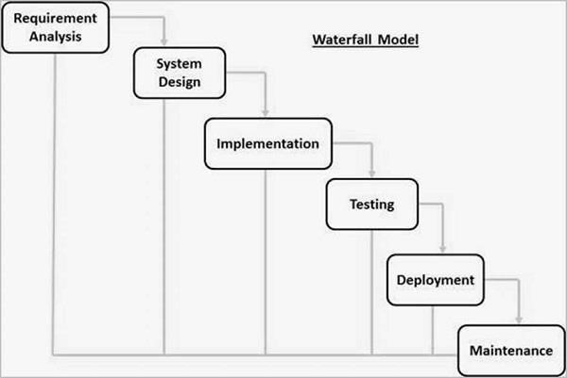

1fig 3.1.5 waterfall model

## **3.2 Requirement Engineering**

Requirement Engineering is the process of identifying, documenting, and maintaining the requirements of a system. It ensures that the final product aligns with user needs and expectations.

3.2.1 Feasibility Study

An initial assessment was conducted to determine the project’s viability. The study concluded that developing an Online Journal Management Information System is feasible, considering the available resources, technical expertise, and institutional support.

3.2.2 Requirement Elicitation

Information was gathered through interviews with potential users, questionnaires, and analysis of existing systems. This process aimed to understand user needs, preferences, and challenges with current journal management practices.

3.2.3 Requirement Analysis

The collected data were analyzed to identify functional and non-functional requirements.

**Functional Requirements:**

User registration and authentication.

Submission and categorization of journals.

Review and approval workflows.

Administrative management of users and content.

**Non-Functional Requirements:**

Usability: The system should be user-friendly and intuitive.

Performance: It should handle multiple concurrent users efficiently.

Security: Protect user data and ensure secure access.

Compatibility: Operate across various devices and browsers.

3.2.4 Requirement Specification

A detailed Software Requirements Specification (SRS) document was created, outlining all identified requirements. This document serves as a reference throughout the development process.

3.2.5 Requirement Validation

The SRS was reviewed and validated with stakeholders to ensure accuracy and completeness. Feedback was incorporated to refine the requirements further.

## **3.3 System Design**

System design translates requirements into a blueprint for constructing the system. It involves creating models that represent the system’s structure and behavior.

3.3.1 Use Case Diagram

Use Case Diagrams illustrate the interactions between users (actors) and the system. The primary actors identified are:

Administrator: Manages users and oversees the system.

Author: Submits journals for publication.

Reviewer: Evaluates submitted journals.

Researcher: Searches and accesses published journals.

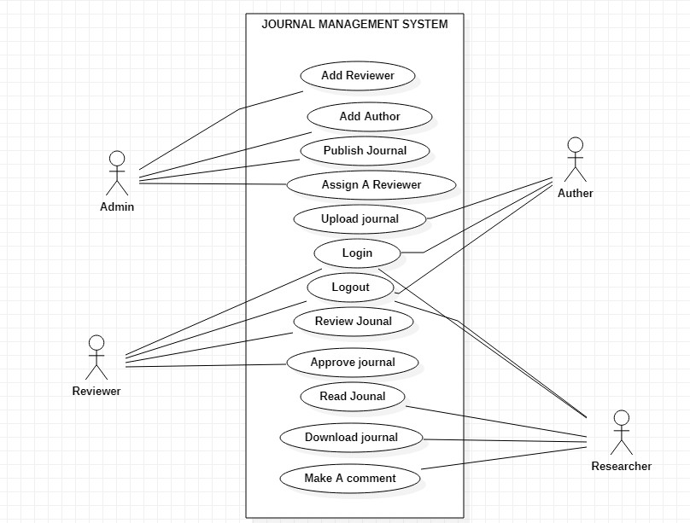

2Figure 3.3.1 Use Case Diagram

3.3.2 Data Flow Diagram (DFD)

DFDs depict the flow of data within the system, highlighting processes, data stores, and external entities.

Level 0 DFD: Provides an overview of the entire system.

Level 1 DFD: Breaks down major processes into sub-processes for detailed analysis.

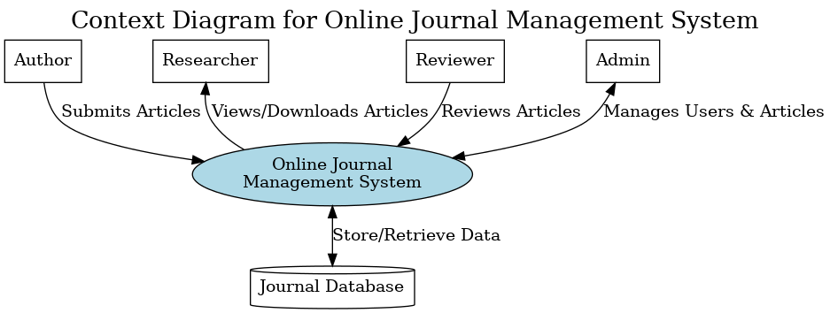

3Figure 3.3.2 : Level 0 and Level 1 DFDs

**3.3.3 Entity-Relationship Diagram (ERD)**

ERDs represent the data model, showing entities, their attributes, and relationships.

Key entities include:

User: Contains user details and roles.

Journal: Stores information about submitted journals.

Review: Records reviewer feedback and decisions.

Download Log: Tracks journal access by researchers.

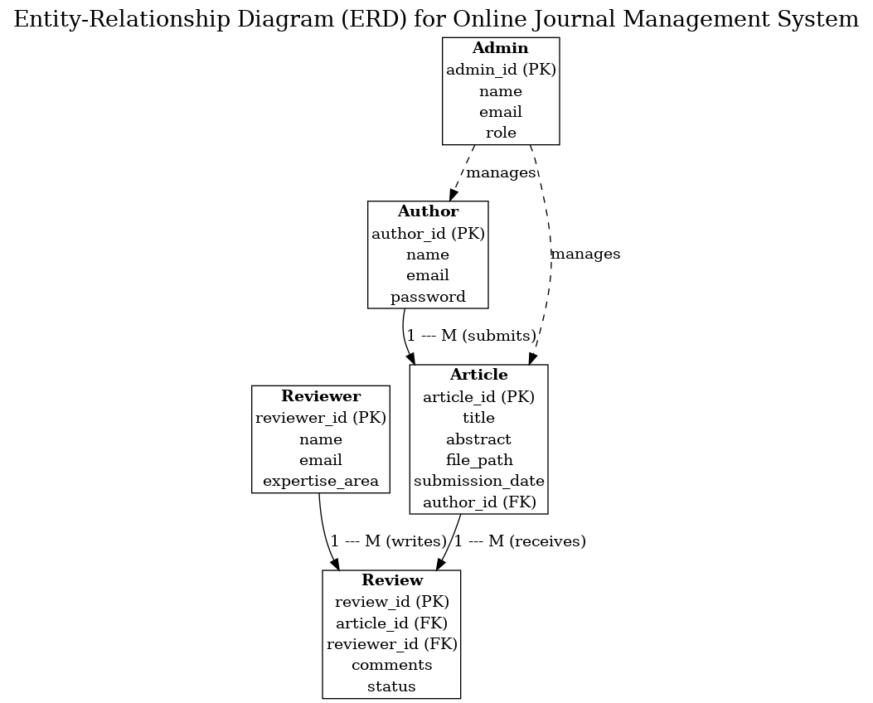

4Figure 3.33 ER Diagram

### 3.3.4 System Architecture

The system adopts a three-tier architecture:

Presentation Layer: User interface developed using HTML, CSS, and JavaScript.

Application Layer: Business logic implemented in PHP.

Data Layer: Database management using MySQL.

This architecture promotes scalability, maintainability, and separation of concerns.

## **3.4 Chapter Summary**

This chapter presented a comprehensive analysis and design of the Online Journal Management Information System. It justified the selection of the Waterfall Model, detailed the requirement engineering processes, and showcased the system’s design through various modeling techniques. These foundational elements are crucial for the successful implementation of the system in subsequent phases.

# **CHAPTER FOUR**

# **SYSTEM IMPLEMENTATION**

## **4.0 Introduction**

This chapter presents the implementation stage of the Online Journal Management Information System. System implementation is the process of translating design specifications into a functioning software product. It involves setting up the software environment, coding the application, and conducting thorough testing to ensure all modules perform as expected. The purpose of this chapter is to demonstrate how the proposed system was realized using selected tools and technologies, and to evaluate its performance after deployment.

## **4.1 Technical Tools Used**

The successful development of the system depended on various tools and technologies. The following outlines the major tools used during implementation and their specific roles:

PHP (v5.3.8): A server-side scripting language used to implement dynamic functionality and server logic.  
HTML/CSS: Used to design the structure and styling of the user interface (frontend), making the system visually appealing and responsive.

MySQL: A relational database management system used to store and retrieve system data such as user records, journal articles, and reviewer information.  
 phpMyAdmin (v3.4.5): A web-based interface used to manage the MySQL database. It allowed convenient manipulation of tables and data entries.  
 XAMPP: An open-source platform used to simulate a local server environment for testing the application before live deployment.  
 Flatlab Template: An HTML admin dashboard template that provided a user-friendly layout for the admin interface and navigation.

## **4.2 System Testing**

System testing was performed to validate the accuracy and performance of all system modules. Black box testing was primarily used, focusing on the outputs generated by the system in response to specific inputs, without examining the internal logic.

**1Table 4.2.1: Sample System Testing Table**

|  |  |  |  |  |  |
| --- | --- | --- | --- | --- | --- |
| TEST ID | FUNCTION | DESCRIPTION | EXPECTED RESULT | ACTUAL RESULT | STATUS |
| 1 | Add new user | Admin tries to add a new user to the system | New users added to the system | New users were added | Successful |
| 2 | Submit manuscript | Author submits a manuscript | Manuscript uploaded | Manuscript uploaded | Successful |
| 3 | Assign reviewer | Admin assigns reviewer to a paper | Reviewer assigned | Reviewer assigned | Successful |
| 4 | Publish article | Admin publishes reviewed and approved paper | Article becomes viewable | Article published successfully | Successful |
| 5 | Login | User attempts to log in with valid credentials | Access granted | User logged in successfully | Successful |

## **4.3 System Requirement**

System requirements describe both the hardware and software needed to run the Online Journal Management Information System efficiently.

**Hardware Requirements:**

Processor: Intel Core i3 and above

RAM: Minimum of 4GB

Hard Disk: At least 500MB of free space

Display: Minimum 1024x768 resolution

**Software Requirements:**

Operating System: Windows 10 or higher / Linux / macOS

Web Browser: Chrome, Firefox, or Edge

Web Server: XAMPP (includes Apache, PHP, MySQL)

Code Editor: Notepad++, VS Code, Sublime Text

Database Management: phpMyAdmin

## 4.4 System Evaluation

System evaluation was carried out by collecting feedback from key stakeholders including students, academic staff, journal reviewers, and system administrators. Methods of evaluation included:

Usability Testing: Selected users were allowed to use the system and provide feedback on the ease of navigation and clarity of features.

Questionnaire and Interviews: Stakeholders were given brief structured questionnaires and interviews were conducted to understand their experience.

Error Reporting and Fixes: Observed issues were documented, and solutions were implemented based on feedback.

Findings:

Users found the system intuitive and easy to navigate.  
Admins appreciated the reviewer assignment and publishing workflow.  
Suggestions included minor UI enhancements and better categorization of published journals.

## 4.5 Chapter Summary

This chapter discussed the implementation of the Online Journal Management Information System, beginning with an overview of the tools and technologies used. It presented a structured testing approach with documented outcomes, detailed the hardware/software requirements, and highlighted stakeholder feedback from the evaluation process. These insights confirm the system’s readiness for deployment and future scalability.

# **CHAPTER FIVE**

# **SUMMARY, CONCLUSION AND RECOMMENDATION**

## **5.0 Introduction**

This chapter presents the final section of the research work. It provides a concise overview and reflection on the entire project, drawing together the key findings and results. It summarizes each chapter, highlights the achievements of the study, and provides logical conclusions based on the analysis and implementation of the system. Furthermore, it offers recommendations for future improvements and adoption of the developed system, and suggests areas for further research in the field of Online Journal Management Systems.

## **5.1 Summary**

The system for Online Journal Management System (A case study of Alqalam University Katsina) has been successfully designed and implemented. This research project consists of five chapters which are summarized as follows:

**Chapter One**: Introduced the background of the study, stated the problem to be solved, outlined the aim and objectives of the study, explained the motivation behind the project, highlighted the scope and limitations, and defined key technical terms used throughout the work.

**Chapter Two**: Reviewed related literature concerning journal systems. It discussed the concept of journals, classification of journals, the emergence and importance of electronic (online) journals, features of online journal systems, and a review of existing platforms in comparison to the proposed system.

**Chapter Three**: Focused on the methodology used for system development. It included the analysis of the current system, data gathering techniques, input and output analysis, system requirements, and modeling using tools like use case diagrams, data flow diagrams (DFD), and Entity Relationship Diagrams (ERD). The chosen software development model was also justified.

**Chapter Four**: Detailed the system implementation phase. It explained the technical tools used in the development such as HTML, PHP, JavaScript, and MySQL. It also included system testing using test cases, discussed hardware and software requirements, presented screenshots of the developed system interfaces, and described the evaluation process.

- Chapter Five: Concludes the entire research work by summarizing the core points, highlighting conclusions drawn from the development and implementation process, offering relevant recommendations, and suggesting future research directions.

## **5.2 Conclusion**

The effort put into this research has led to the successful development of an Online Journal Management System tailored for use by Journal Administrators. The system solves many of the limitations encountered in traditional paper-based or semi-digital systems. With features such as article submission, editorial review, publication tracking, and user management, the system meets its initial objectives. It streamlines operations, reduces manual workload, and provides a platform accessible over the internet. The project goals have been achieved, and if fully adopted and maintained, the system will greatly enhance journal management efficiency and accessibility.

## **5.3 Recommendation**

Based on the successful development of the new system for Journal Management at Al-Qalam University, Katsina, the following recommendations are made:

- The system should be hosted on a reliable server and made publicly available on the World Wide Web(WWW) to allow remote access and attract a wider range of users and researchers globally.

- Content within the system such as 'Call for Papers,' 'Editorial Notices,' and 'Publication Schedules' should be frequently updated to maintain relevance and engagement.

- The system should be advertised using various communication channels such as university bulletin boards, academic conferences, newspapers, online platforms, and through academic partnerships.

- Users, especially journal editors and administrators, should be trained on how to effectively use and manage the system to ensure full utilization.

- Regular security audits, backups, and maintenance routines should be conducted to ensure the system remains secure, reliable, and free from vulnerabilities.

- A feedback option should be integrated into the system to allow users to suggest improvements, report bugs, or raise concerns.

# **REFERENCES**

Adebayo, A. A., Yusuf, K. O., & Okon, C. I. (2022). E-learning technologies and academic research post COVID-19 in Nigeria. Journal of Educational Innovation and Research, 14(2), 99–112.

Al-Adwan, A. S., & Berger, H. (2022). Adoption of open access platforms: A study of academic journal systems. Journal of Information Science, 48(3), 344-357. https://doi.org/10.1177/0165551521994989

Davis, F. D. (2021). Perceived usefulness, perceived ease of use, and user acceptance of information technology. MIS Quarterly, 13(3), 319–340. https://doi.org/10.2307/249008

Diagrams.net. (2024). Diagrams.net. https://en.wikipedia.org/wiki/Diagrams.net

Eysenbach, G. (2022). Peer review management in online journal systems: Opportunities and challenges. Journal of Medical Internet Research, 24(1), e23498. https://doi.org/10.2196/23498

Fatima, N., & Idris, A. Y. (2022). Cybersecurity threats in academic IT systems: A case study in Nigerian universities. Journal of Information Security and Applications, 68, 103153. https://doi.org/10.1016/j.jisa.2022.103153

Fombad, M. C., & Mutula, S. M. (2023). Digital transformation in scholarly publishing: The role of online journal systems. Information Development, 39(2), 146-158. https://doi.org/10.1177/02666669221109184

Hammer, M. (2021). Workflow automation: Enabling operational excellence in information systems. Business Process Management Journal, 27(6), 1897-1915. https://doi.org/10.1108/BPMJ-09-2020-0443

Heyn, H.-M., Knauss, E., Muhammad, A. P., Eriksson, O., Linder, J., Subbiah, P., Pradhan, S. K., & Tungal, S. (2021). Requirement Engineering Challenges for AI-intense Systems Development. arXiv preprint arXiv:2103.10270. https://arxiv.org/abs/2103.10270

Ibrahim, T., Usman, M., & Garba, Y. A. (2021). Mobile compatibility and accessibility of online journal systems in Nigerian tertiary institutions. African Journal of Computing & ICT, 14(3), 33–41.

Jacobs, M., & Brown, S. (2021). Metadata management in digital publishing: A case study of academic journals. Library Management, 42(8/9), 529-541. https://doi.org/10.1108/LM-02-2021-0021

Kasauli, R., Knauss, E., Nakatumba-Nabende, J., & Kanagwa, B. (2021). Agile Islands in a Waterfall Environment: Requirements Engineering Challenges and Strategies in Automotive. arXiv preprint arXiv:2106.11187. https://arxiv.org/abs/2106.11187

Khan, U., & Ahmad, B. (2021). Transitioning from manual to automated journal publishing in South Asian universities. Asian Journal of Technology in Education, 6(1), 14–25.

Kumar, A., & Singh, P. (2021). Cybersecurity challenges in online journal management systems. Information Security Journal: A Global Perspective, 30(1), 20-28. https://doi.org/10.1080/19393555.2020.1850519

Laudon, K. C., & Laudon, J. P. (2022). Management information systems: Managing the digital firm (17th ed.). Pearson.

Mohammed, S., & Abubakar, H. A. (2022). Adoption of research information systems in Nigerian academia. Nigerian Journal of Software Engineering, 4(1), 25–36.

Musa, B. I., & Okafor, C. (2022). Enhancing research impact through digital journal management systems. Open Access Research Review, 10(4), 50–63.

Norman, D. A. (2022). The design of everyday things (Revised and expanded edition). Basic Books.

Oluwatosin, F., & Musa, L. (2023). Exploring mobile-friendly academic platforms in sub-Saharan Africa. Journal of Mobile Computing and Education, 9(2), 80–94.

Osei, E., & Boateng, R. (2022). Mobile accessibility in academic publishing systems: Challenges and opportunities. The Electronic Library, 40(3), 359-373. https://doi.org/10.1108/EL-07-2021-0173

Smith, R., & Anderson, T. (2021). Usability issues in open access journal management platforms. Online Information Review, 45(2), 250-266. https://doi.org/10.1108/OIR-06-2020-0241

StarUML. (2023). StarUML. https://en.wikipedia.org/wiki/StarUML

UNESCO. (2023). Reimagining our futures together: A new social contract for education. Retrieved from https://www.unesco.org/en/digital-education

Usman, A., Adamu, L., & Saidu, S. (2021). Peer review challenges in Nigerian academic publishing: Toward automated solutions. Journal of Scholarly Publishing in Africa, 8(1), 44–59.

Whitman, M. E., & Mattord, H. J. (2021). Principles of information security (7th ed.). Cengage Learning.

Willinsky, J. (2021). The access principle: The case for open access to research and scholarship. MIT Press.

Zainab, A. N., Abrizah, A., & Kiran, K. (2023). Automation of editorial workflows in journal management systems: A systematic review. Information Development, 39(1), 34-46. <https://doi.org/10.1177/02666669211065443>

# **APPENDIX A**

1. **WELCOME PAGE**

The welcome page shows the first appearance of the system, which include the picture of the university and the option of the login phase.



fig 5.1 welcome page

**2. ADMIN LOGIN PAGE**

This consists of two widgets, a text area for entering username along with its label. The user

must enter a valid user name and password.

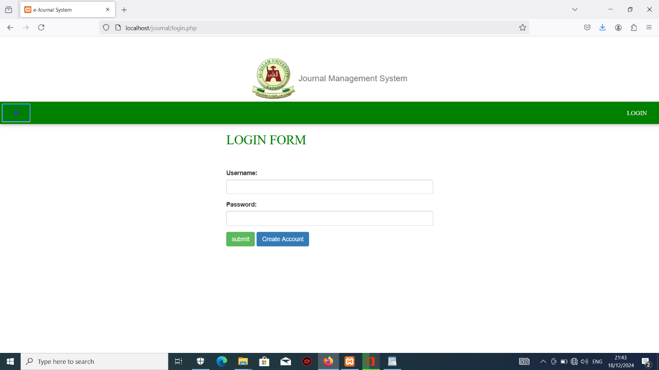

fig 5.2 admin login page

**3. PUBLISHED JOURNAL PAGE**

The published journal page shows the journal/articles that are been published, and it shows the status published as indicated in the page.

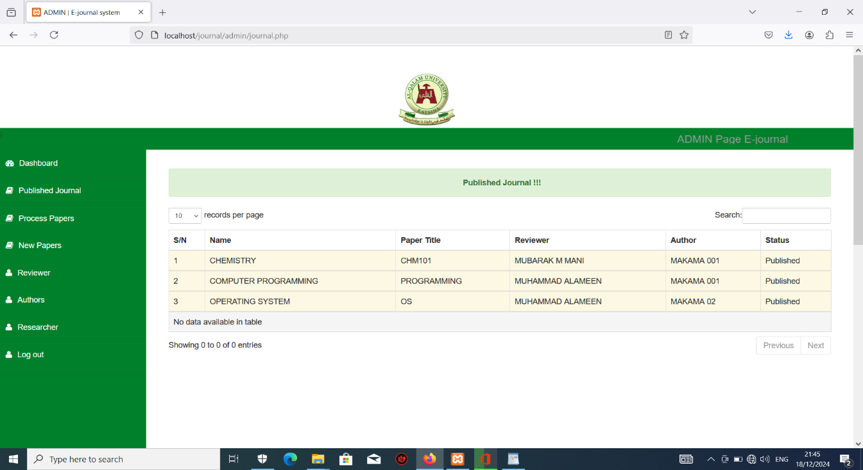

fig 5.3 published journal page

**4. PROCESS PAPER PAGE**

The process paper page shows the record of the papers that are on process or under review, it also shows the status of the processes weather it is assigned or it is pending.

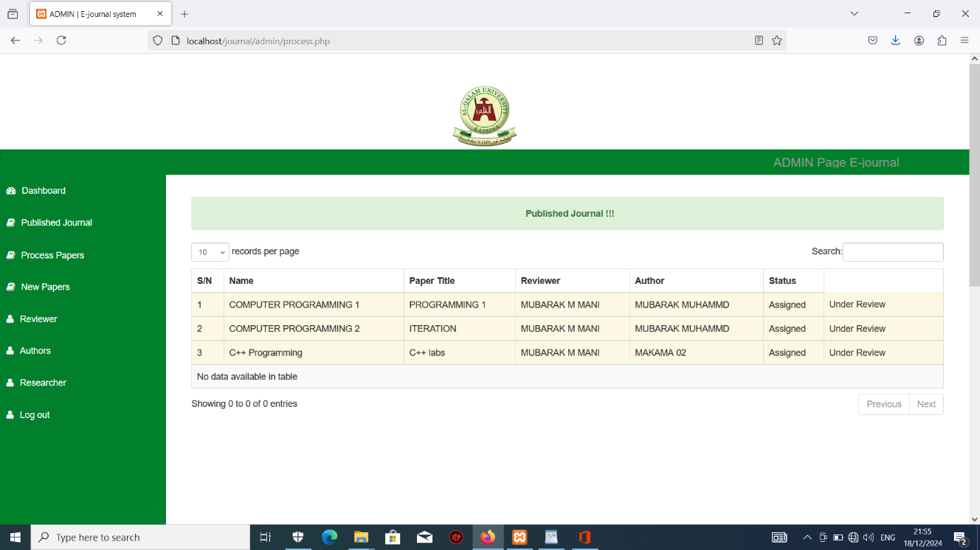

fig 5.4 process paper page

**5. NEW PAPERS**

The new papers page shows the journals that are just uploaded in the system as recent articles, and they are ready for processing, it indicate the assign button.

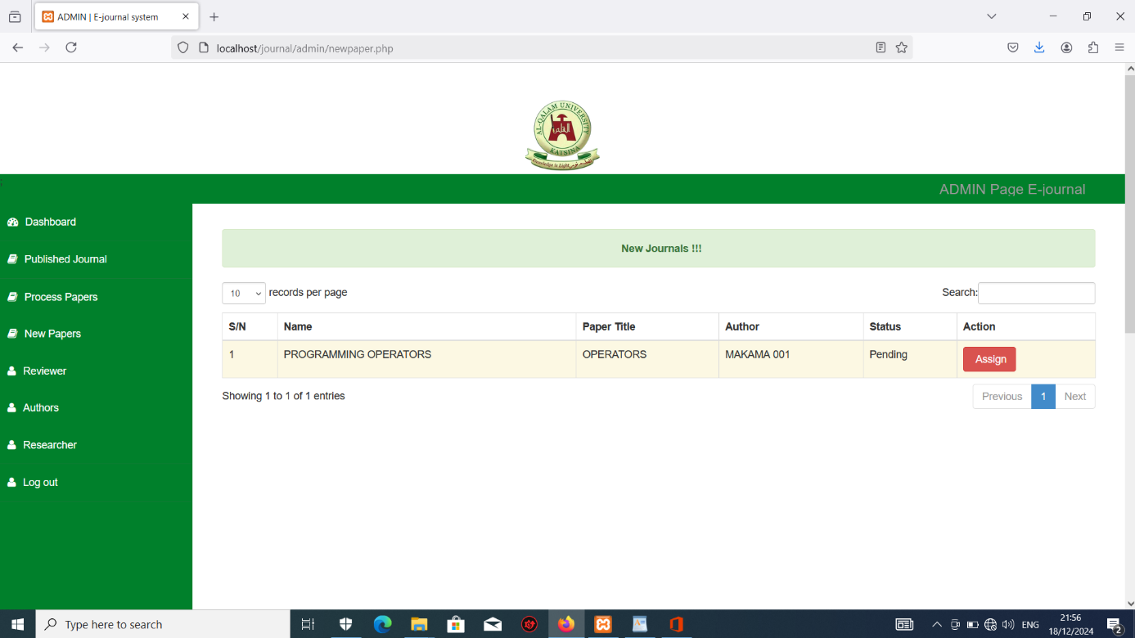

fig 5.5 new papers page

**6. REVIEWER PAGE**

The reviewer page shows the number of reviewers of a particular paper or journal, it also include an option for the admin to add many reviewers if possible and to delete or remove a reviewer if need be.

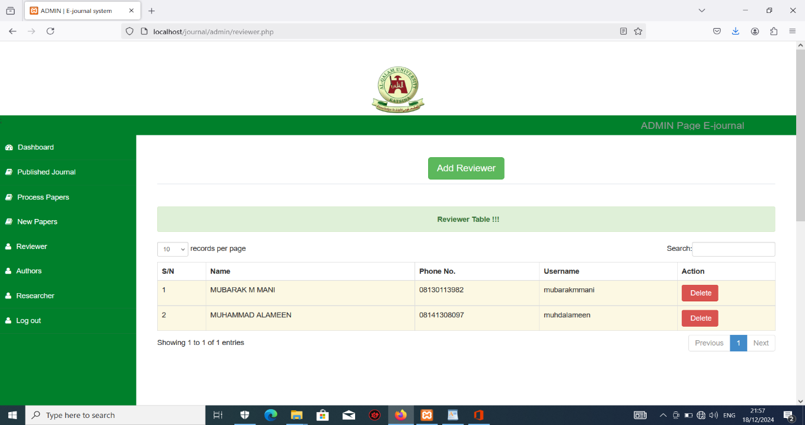

fig 5.6 reviewer page

**7. AUTHORS PAGE**

sThe authors page shows the number of reviewers of a particular paper or journal, it also include an option for the admin to add many authors if possible and to delete or remove an authors if need be.

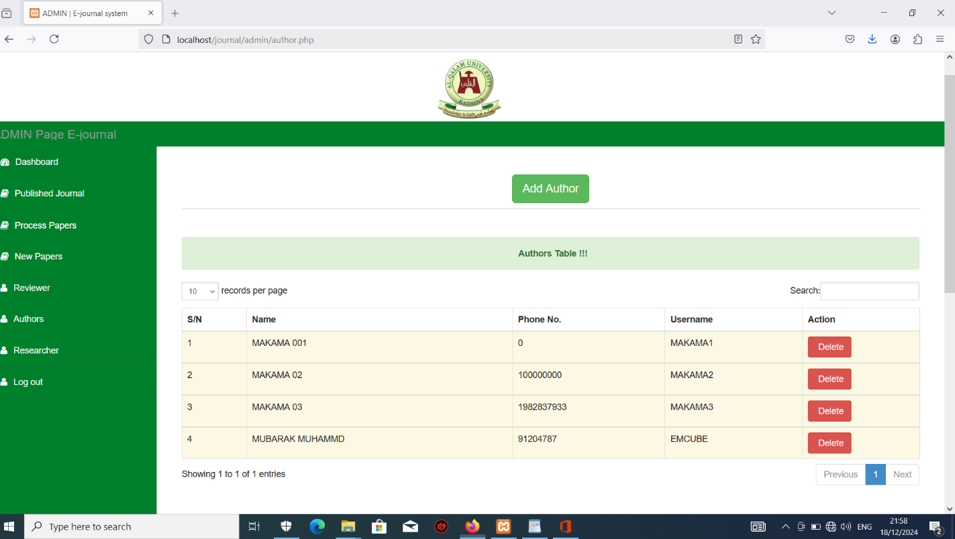

fig 5.7 authors page

**8. RESEARCHER PAGE**

The researcher page shows the number of researcher and their username, name and phone number.

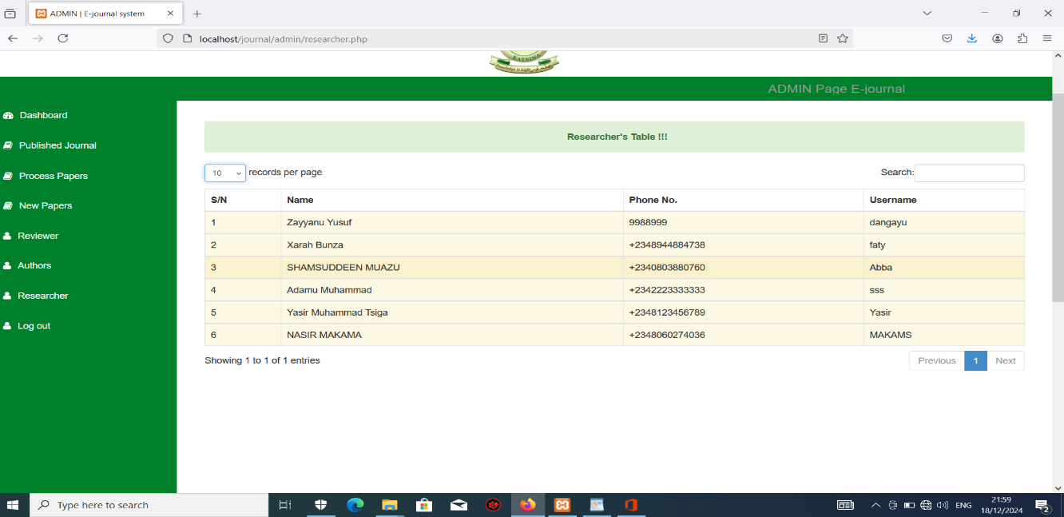

fig 4.6.8 researcher page

# **APPENDIX B**

https://github.com/naseermakama/Online_Journal_System

## **APPENDIX C**

## **Forms and Other Relevant Information**

**C.1 Article Submission Form (Sample)**

Field Input Type

Title Text Field

Author Name Text Field

Email Email Field

Affiliation Text Field

Abstract Text Area (Multi-line)

Keywords Text Field

Manuscript Upload File Upload (PDF/DOC)

Journal Section Dropdown or Checkboxes (Research Article, Review Article, etc.)

Declaration Checkbox

Date/Signature Date Picker / Text Line

**C.2 Reviewer Evaluation Form**

Evaluation Criteria:

Criteria Excellent Good Fair Poor

Originality ☐ ☐ ☐ ☐

Relevance to Journal Scope ☐ ☐ ☐ ☐

Research Methodology ☐ ☐ ☐ ☐

Language and Clarity ☐ ☐ ☐ ☐

Reference Accuracy ☐ ☐ ☐ ☐

Comments:

(Text area for detailed reviewer comments)

Recommendation:

☐ Accept

☐ Minor Revisions

☐ Major Revisions

☐ Reject

**C.3 Editorial Decision Form**

Field Description

Article ID Auto-generated by system

Title Populated from submission

Editor Name Current logged-in editor

Editorial Comment Textarea

Final Decision Dropdown (Accept, Revise, Reject)

Date of Decision Auto-generated or manually entered

**C.4 User Registration Form**

Field Input Type

Full Name Text

Email Address Email

Phone Number Tel

Affiliation Text

Role Selection Dropdown (Author, Reviewer, Editor)

Username Text

Password Password Field

Confirm Password Password Field

Accept Terms Checkbox

Signature & Date Text / Date Picker

**C.5 User Roles Summary Table**

User Role Responsibilities

Author Submit articles, track status, revise submissions

Reviewer Evaluate assigned papers, submit feedback

Editor Assign reviewers, make editorial decisions

Admin Manage users, monitor system security, oversee operations

**C.6 Notes on System Workflow**

The entire workflow (submission → review → decision → publication) is managed online through role-specific dashboards.

Forms are validated to prevent incorrect data entry.

Submitted manuscripts are stored securely and linked to the author and journal issue.